CALL FOR CONTRIBUTION
24th XBRL Europe day - Scheme for partnership and Cost participation to catering
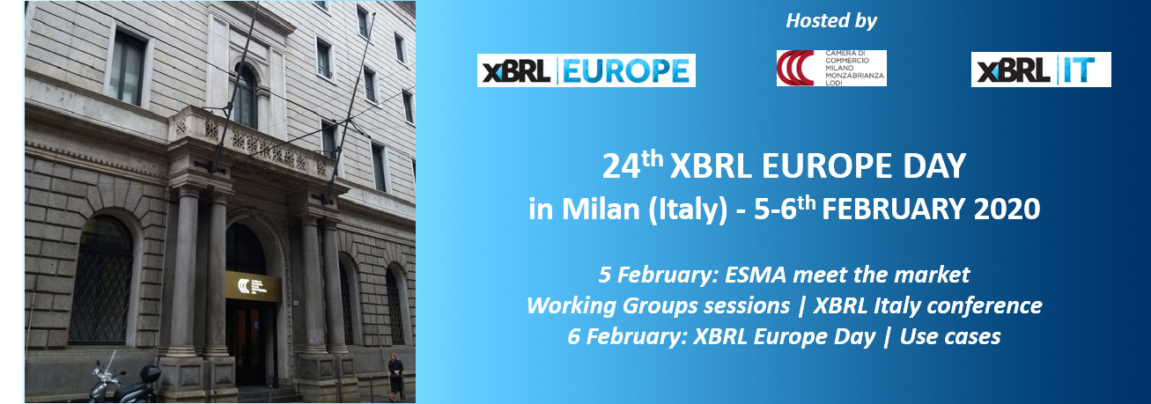
We are invited to meet at the Chamber of Commerce of Milan, thanks to XBRL Italy. To cover the additional costs for the logistics and catering, which usually require between 6000 and 8000 euros for lunch, coffee breaks and videorecording, we ask the kind support of our members.
PARTNERSHIP MODELS

- Event Partner: 500 €
  - Rewarded by your name and logo mentioned amongst the partners, on all documents (guide, website)
  - With a short presentation (text) in the paper-based guide (& PDF)

- Inviting Partner: 2 000 €
  - Allows to invite external guests to the event (max 5) and to have a table to give demo to those guests and other participants (a kakemono or documents may be displayed)
  - Rewarded by your name and logo mentioned amongst the partners, on all documents (guide, website)
  - With an institutional presentation (with graphics) in the paper-based guide (& PDF)

The event is open to the staff of XBRL Europe direct members and participants (members of jurisdictions). Limitations in the number of people apply and any registration must be confirmed. If you would like to invite more people or additional contacts, please consider the Inviting Partnership Package.
XBRL Europe Premium members have logo mentioned on all documents during the year.
Discounted price for the Inviting package: 1 200 €

THE CONCEPT

The next XBRL Europe Day, Winter Session, will take place in Milan on 5-6 February 2020 at the Chamber of Commerce – Via Meravigli, 9/b, 20123 Milano (Italy).

XBRL Europe members and participants are welcome. They are invited to join the plenary session, participate to the working groups and task forces about ESEF, Bank & Insurance Reporting, Standard Business Reporting, Business Registers and others. See details on website xbrleurope.org

THE TIMING

Wednesday 5th of February

- 10:00 – 12:00 – ESMA Meet the market technical session,
dedicated to the dual filers service providers.
- 14:00 – 18:00 – XBRL Italy Conference
- 14:00 – 16:00 – XBRL Europe OAM&BR WG (restricted)
- 14:00 – 16:00 – XBRL Europe Bank & Insurance WG
- 14:00 – 16:00 – Calc 2 & OIM XII WGs
- 16:00 – 16:30 – Coffee break
- 16:30 – 18:00 – XBRL Europe SBR WG
- 16:30 – 18:00 – XBRL Europe BPTF ESEF
- 16:30 – 18:00 – XBRL Europe ESG WG
- 20:00 – Friendly dinner

Thursday 6th of February

- 09:00 – 09:05 – Welcome words
- 09:05 – 10:50 – Plenary first section
- 10:50 – 11:10 – Coffee break
- 11:10 – 12h40 – Plenary second section
- 12:45 – 14:00 – Lunch
- 12:45 – 17:00 – Private software demos on Inviting Partners Tables
- 14:00 – 15:30 – Use cases and innovations demos
- 17:00 – Closing remarks

What is XBRL Europe?

XBRL Europe, a regional organization of XBRL International is a non-profit organization for the promotion of XBRL in Europe, with 35 members in 2020.
XBRL Europe has been set up to foster European XBRL efforts and to implement common XBRL projects in Europe between its members and to liaise with European Authorities and organizations. XBRL Europe develops its activities through working groups and their deliverables and through conferences twice a year, the so called XBRL Europe days.

XBRL Europe members
JURISDICTIONS AND EU INSTITUTIONS & FEDERATIONS
XBRL Denmark ; XBRL Finland ; XBRL France ; XBRL Germany ; XBRL Italy ; XBRL Netherland ; XBRL Sweden ; XBRL United Kingdom ; EFFAS
XBRL EUROPE AND ITS PREMIUM MEMBERS
DFIN Solutions ; Ernst & Young EMEIA ; Invoke ; Julhiet Sterwen ; Labrador ; PwC ; XBRL Express
SILVER MEMBERS
Anubo ; AxiomSL; Bank Al-Maghrib; BRAG; Bundesanzeiger Verlag GmbH ; Certent ; DataTracks ; Fujitsu ; GPM ; Infogreffe ; Iris Business Services Ltd ; Oracle ; Parseport ; Reporting Estandar ; Studio Lupini ; TESH Advice; Toppan Merrill ; UBPartner ; Workiva

THE VENUE

Chamber of Commerce of Milan - Address: Via Meravigli, 9/b, 20123 Milano MI

EXPECTED VISITORS

Circa 100/150 attendees comprised of:
- XBRL Europe members and participants (members of XBRL jurisdictions)
- Other stakeholders (regulators, authorities, issuers, preparers etc.)
- Guests invited by Inviting Partners
- Guests invited by XBRL Italy

INFORMATIONS REGARDING THE COMPANY

Company’s name

Name and first name

Position

Direct phone number

E-mail

Billing Address

Intercommunity VAT

Your support : Standard Partner ☐ Inviting Partner ☐
Additional options: ………………………………………………….
Payment on receipt of the invoice of ……….…,oo €
Signature and title ……………………………………………………. Agreed and signed
And stamp of the organization Date ……………………………………
YOUR CONTACT
Corinne.laurie@xbrl-eu.org- www.xbrl.europe.org -
Tel. 33 1 47 50 00 50 - Mob. 33 6 32 24 66 39 -
Return the completed order form to info@xbrl-eu.org

